[CEN 323 ] Computer Organization & Assembly Language
Lab 10 Journal

Name :Bilal Aamir
Enrollment Number:01-135232-016

Lab Deliverables (submission guideline)

Create a folder named after your enrollment number and add the following files:
  - Create a folder named YourRollNumber_Lab10 containing:
- .asm files of the Three Practice tasks.
- .asm files of the Two Unseen tasks.
- Add full screen screenshots of the code and output in this word file.
  - Zip the Folder and upload it to LMS.

Lab Task

Task 1:
Code (TEXT):
include emu8086.inc
.model big

.data
msg db "The sum of these 5 numbers is : $"
ten db 10
rem db ?
quo db ?

MyMacro Macro
Local Label,double,Cont
mov cx,5
mov bl,0
Label:
Print "Enter the number : "
mov ah,01h
int 21h

sub al,48
add bl,al
PrintN ""
Loop Label

mov ah,09h
LEA dx,msg
int 21h

CMP bl,9
JA double

mov dl,bl
add dl,48
mov ah,02h
int 21h

jmp Cont
double:
xor ax,ax
mov al,bl

div ten

mov quo,al
add quo,48
mov rem,ah
add rem,48
mov ah,02h
mov dl,quo
int 21h
mov dl,rem
int 21h

Cont:
PrintN ""
ENDM
.code
mov ax,@data
mov ds,ax
mov cx,5
MyLoop:
push cx
MyMacro
pop cx
Loop MyLoop
mov ah,4Ch
int 21h
Screenshot (CODE):

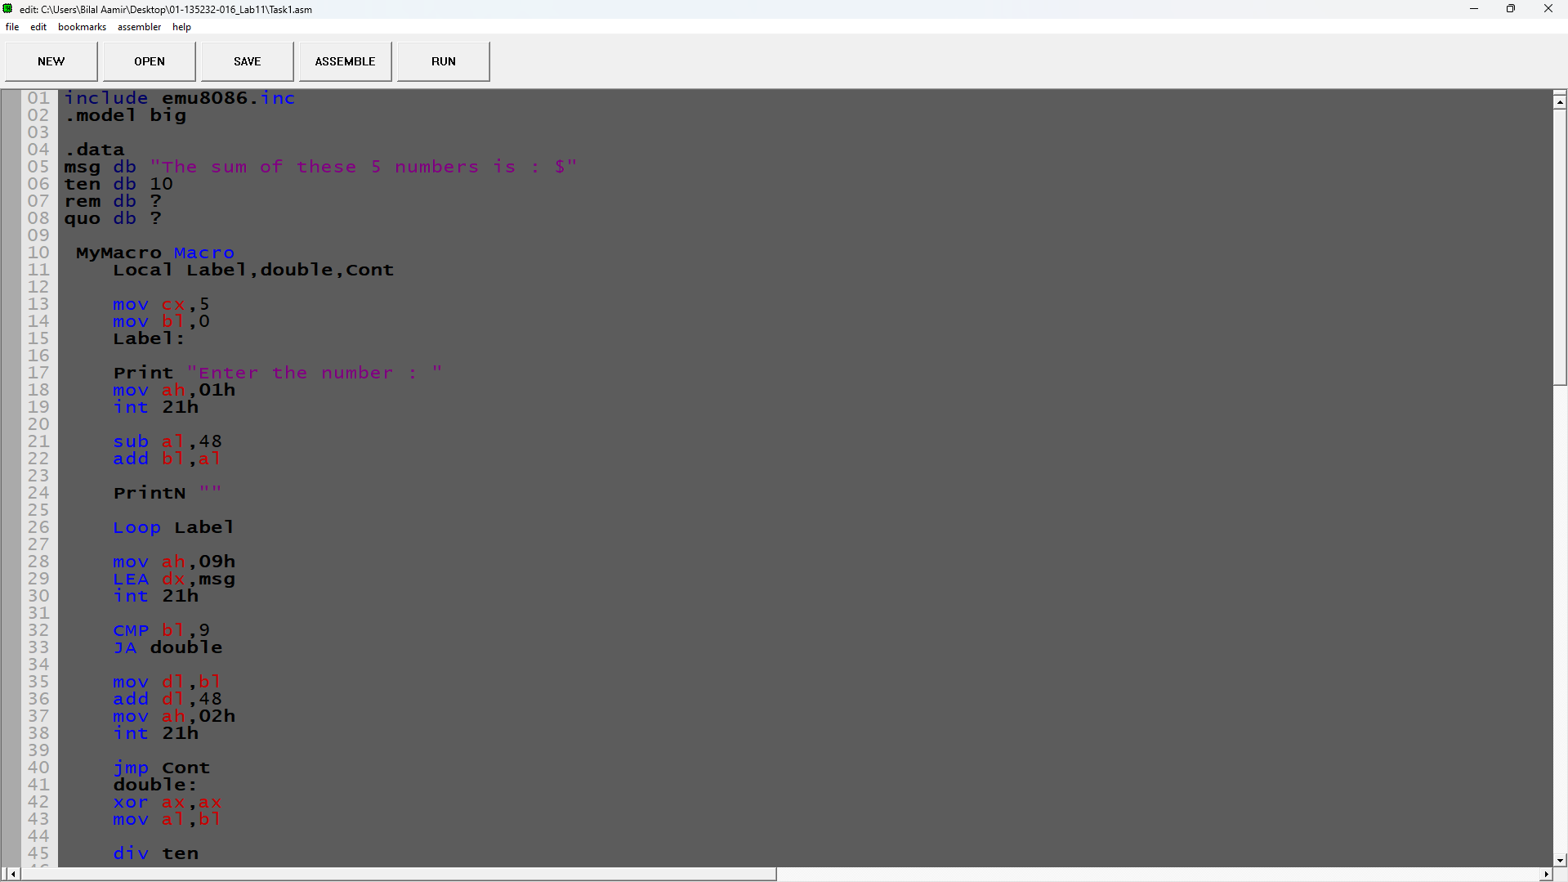

Screenshot (OUTPUT):
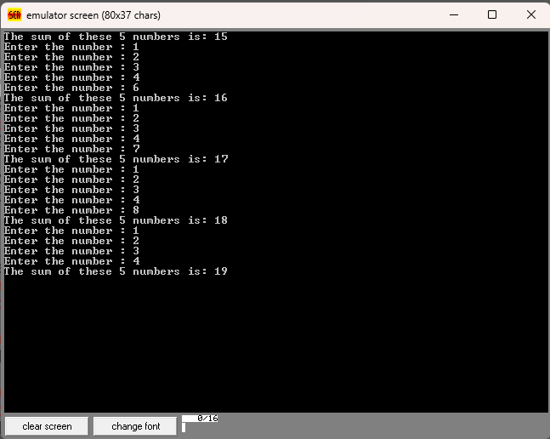

Task 2:
Code (TEXT):
include emu8086.inc
.model small

.data
num1 db ?
num2 db ?
Ten db 10
quo db ?
rem db ?

MyMacro MACRO var1,var2
Local Double,Cont
Print "The result is : "
xor ax,ax
xor bx,bx
mov al,var1
mov bl,var2

MUL bl
PUSH AX

CMP ax,9
JA Double

mov dl,al
add dl,48
mov ah,02h
int 21h

jmp Cont

Double:

xor ax,ax
POP AX

div ten

mov quo,al
add quo,48

mov rem,ah
add rem,48

mov ah,02h
mov dl,quo
int 21h
mov dl,rem
int 21h

Cont:
PrintN ""
ENDM

.code
mov ax,@data
mov ds,ax

Loopp:
Print "Enter the first number : "
mov ah,01h
int 21h
sub al,48

mov num1,al
PrintN ""
Print "Enter the second number : "
mov ah,01h
int 21h
sub al,48

mov num2,al

CMP num1,0
JNE Multiply

CMP num2,0
JE Exit

Multiply:

PrintN ""

MyMacro num1,num2

JMP Loopp

Exit:
PrintN ""
Print "You Entered Two 0s "
mov ah,4Ch
int 21h

Screenshot (CODE):
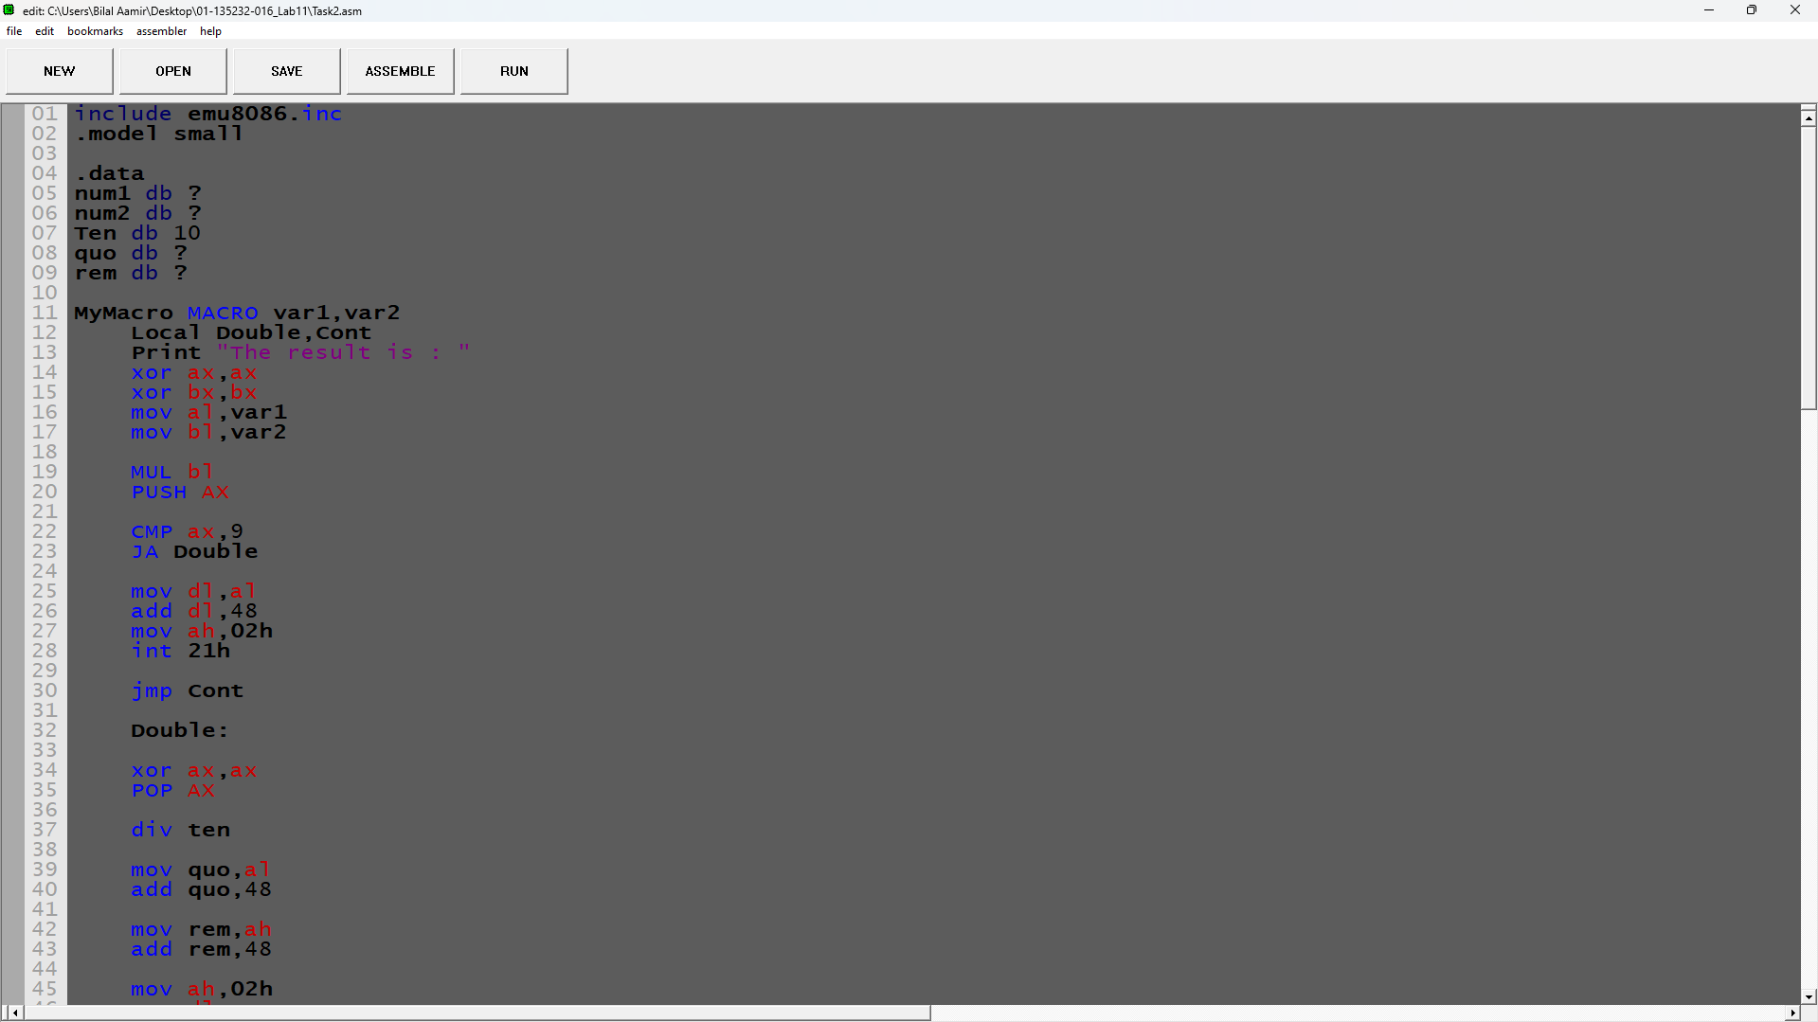

Screenshot (OUTPUT):
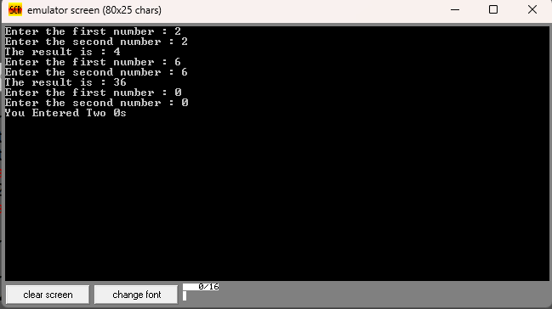

Task 3:
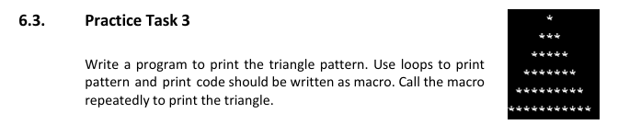
Code (TEXT):
include emu8086.inc
.model small

.data
count dw 1
spaces db 32
stars db 42
pattern macro var
local PrintSpaces,Exitspaces,PrintStars,ExitStars
PUSH count

mov bx,var
sub bl,1
PrintSpaces:
CMP bl,0
JE Exitspaces
putc spaces
dec bl
jmp PrintSpaces

Exitspaces:

PrintStars:
CMP count,0
JE ExitStars
putc stars
dec count
jmp PrintStars

ExitStars:
PrintN ""

POP count
add count,2

ENDM

.code
mov ax,@data
mov ds,ax

mov cx,6

PatternLoop:

pattern CX

Loop PatternLoop

mov ah,4Ch
int 21h

Screenshot (CODE):
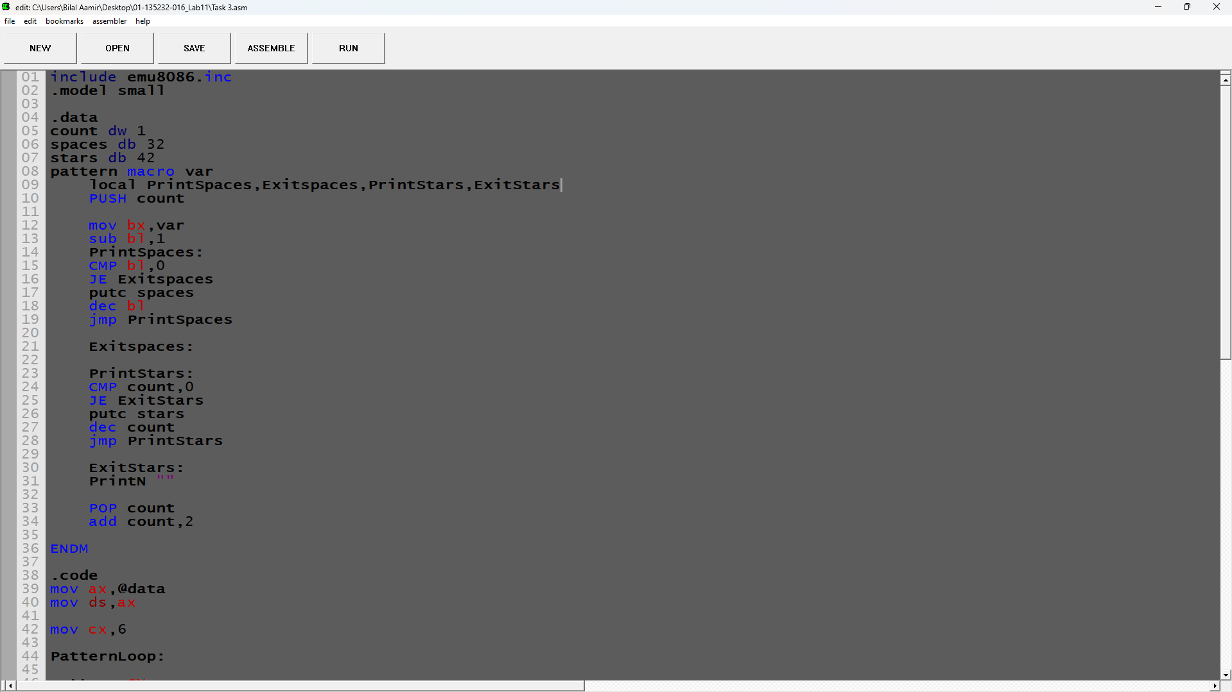

Screenshot (OUTPUT):
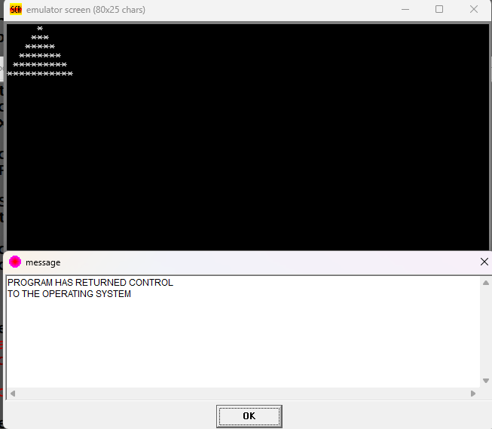

Unseen Task 1:
Make a macro which takes one parameter 'rows' and prints a following pattern with the number of rows given by the user. Invoke the macro in a loop and keep printing the patterns of the given height until user presses enter key.
*
**
***
****

Code (TEXT):
include emu8086.inc
.model small

.data
msg db "You pressed enter key $"
innercount db 1
Pattern MACRO rows
local numofrows,Exit,InnerLoop,repeat
mov innercount,1

mov cl,rows

repeat:
push cx

mov cl,innercount

InnerLoop:

putc '*'

loop InnerLoop

PrintN ""

pop cx

inc innercount

loop repeat

ENDM

.code
mov ax,@data
mov ds,ax

Loopp:

PrintN "Press the number of rows You want to Print Or Press Enter to Stop Printing "

mov ah,01h
int 21h

PrintN ""

CMP al,13
JE Exit

sub al,48
Pattern al
jmp Loopp
Exit:

mov ah,09h
LEA dx,msg
int 21h

mov ah,4Ch
int 21h

Screenshot (CODE):
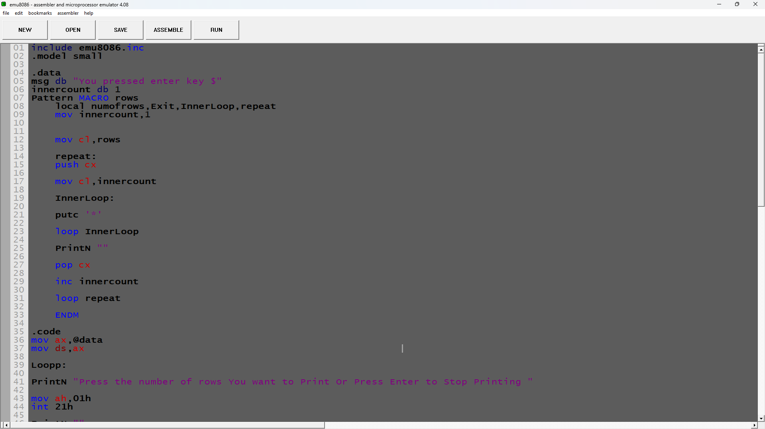

Screenshot (OUTPUT):
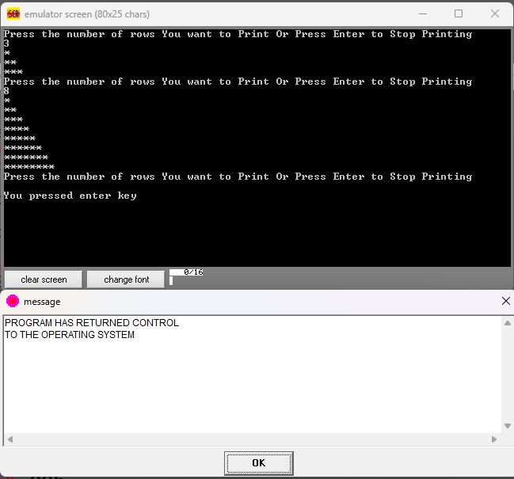

Unseen Task 2:
Make a macro which takes a number as a parameter and handles the output of multiple digits (up to 3 digits).
- If 3 digits are entered the number will automatically be taken as the input.
- User can press the enter key to finish entering the number prematurely.

Code (TEXT):
include emu8086.inc
.model small

.data
count db 0
quot db ?
rem db ?
num db ?
num_count db 0

input macro
local Input,Store,Double,Tripple,Exit

xor dx,dx

Print "Enter the number : "
PrintN ""

Input:

CMP count,3
JE Exit

mov ah,01h
int 21h

CMP AL,13
JE Store

inc count
sub al,48

CMP count,2
JE Double

CMP count,3
JE Tripple

mov num,al
mov dl,num

JMP Input
Double:

mov AH,0
mov BL,10

XCHG num,AL
MUL BL
add AL,num

MOV DX,AX
mov num,dl

JMP Input
Tripple:

mov AH,0 ;Clear AH for correct Multiplication
mov BL,10 ;Store 10 in BL to multiply with new number to form hundreds

xchg num,AL

MUL BL

xor bx,bx ;Clear BX for storing num in it
mov bl,num ;mov num into lower BX
ADD AX,BX ;add newly entered number into tripple digit number built
mov DX,AX ;mov into DX so the built number can be pushed into stack

Store:

PUSH DX ;The final number stored in the stack
PrintN ""
inc num_count
xor DX,DX

Exit:

ENDM

output macro numb
local single,double,

Print "The number you entered is : "
CMP count,1 ;Is it a one digit number ?
JE single

CMP count,2 ;Is it a two digit number ?
JE double

mov ax,numb ;Its a three digit number
mov bl,100

Div bl

mov quot,al
mov rem,ah

mov dl,quot
add dl,48
mov ah,02h
int 21h

mov bl,rem
mov numb,bx

double:

mov ax,numb

xor bx,bx
mov bl,10

Div bl

mov quot,al
mov rem,ah

mov dl,quot
add dl,48
mov ah,02h
int 21h

mov bl,rem
mov numb,bx

single:

mov dx,numb
add dl,48
mov ah,02h
int 21h

ENDM

.code

mov ax,@data
mov ds,ax

input
POP CX
output CX

mov ah,4ch
int 21h

Screenshot (CODE):
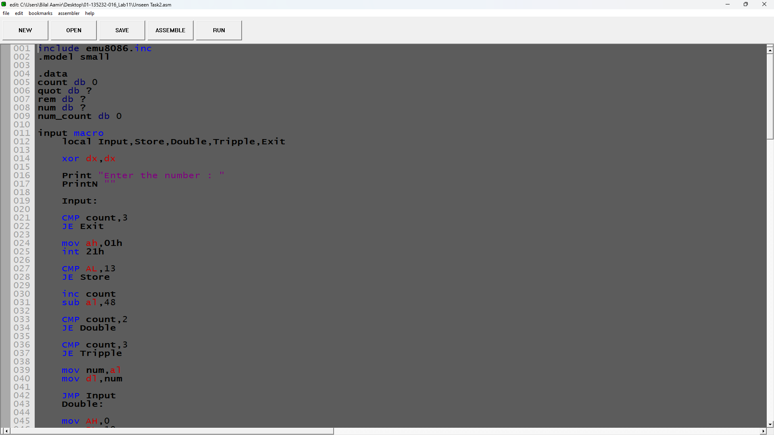

Screenshot (OUTPUT):
